Hands-on 1: Spring Data JPA - Quick Example
Spring Data JPA makes it easy to perform database operations by reducing the amount of code that developers need to write. It works with Hibernate to map Java objects to database tables and provides built-in methods for accessing data without writing SQL queries.

Code
1. Country.java
package orm_learn.model;
import jakarta.persistence.Column;
import jakarta.persistence.Entity;
import jakarta.persistence.Id;
import jakarta.persistence.Table;
@Entity
@Table(name = "country")
public class Country {
@Id
@Column(name = "co_code")
private String code;
@Column(name = "co_name")
private String name;
public Country() {
}
public Country(String code, String name) {
this.code = code;
this.name = name;
}
public String getCode() {
return code;
}
public void setCode(String code) {
this.code = code;
}
public String getName() {
return name;
}
public void setName(String name) {
this.name = name;
}
@Override
public String toString() {
return "Country{code='" + code + "', name='" + name + "'}";
}
}
2. CountryRepository.java
package orm_learn.repository;
import org.springframework.data.jpa.repository.JpaRepository;
import org.springframework.stereotype.Repository;
import orm_learn.model.Country;
@Repository
public interface CountryRepository extends JpaRepository<Country, String> {
}
3. CountryService.java
package orm_learn.service;
import java.util.List;
import org.springframework.beans.factory.annotation.Autowired;
import org.springframework.stereotype.Service;
import jakarta.transaction.Transactional;
import orm_learn.model.Country;
import orm_learn.repository.CountryRepository;
@Service
public class CountryService {
@Autowired
private CountryRepository countryRepository;
@Transactional
public List<Country> getAllCountries() {
return countryRepository.findAll();
}
}
4. OrmLearnApplication.java
package orm_learn;
import java.util.List;
import org.springframework.boot.SpringApplication;
import org.springframework.boot.autoconfigure.SpringBootApplication;
import org.springframework.context.ApplicationContext;
import orm_learn.model.Country;
import orm_learn.service.CountryService;
@SpringBootApplication
public class OrmLearnApplication {
public static void main(String[] args) {
ApplicationContext context = SpringApplication.run(OrmLearnApplication.class, args);
CountryService countryService = context.getBean(CountryService.class);
List<Country> countries = countryService.getAllCountries();
System.out.println("Countries in Database:");
for (Country country : countries) {
System.out.println(country);
}
}
}
5. application.properties
logging.level.org.springframework=info
logging.level.com.cognizant=debug
logging.level.org.hibernate.SQL=trace
logging.level.org.hibernate.type.descriptor.sql=trace
spring.datasource.driver-class-name=com.mysql.cj.jdbc.Driver
spring.datasource.url=jdbc:mysql://localhost:3306/ormlearn
spring.datasource.username=root
spring.datasource.password=root
spring.jpa.hibernate.ddl-auto=validate
Output
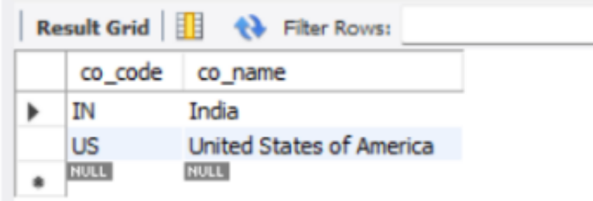
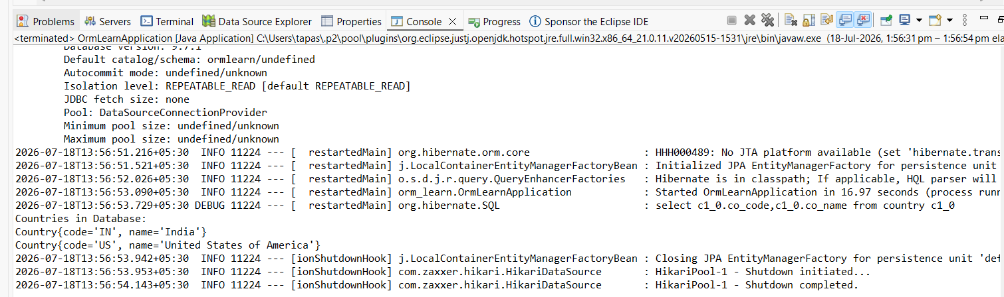
Result
The Spring Boot application was successfully connected to the MySQL database using Spring Data JPA and Hibernate. The application retrieved the country records from the country table and displayed them successfully in the Eclipse console.

Hands-on 2: Difference between JPA, Hibernate and Spring Data JPA

JPA | Hibernate | Spring Data JPA
JPA stands for Java Persistence API. | Hibernate is an ORM framework that implements JPA. | Spring Data JPA is a Spring module that simplifies JPA development.
It is a specification, not a framework. | It provides the actual implementation of JPA. | It reduces the amount of code required for database operations.
It defines rules for object-relational mapping. | It converts Java objects into database records. | It provides built-in methods like save(), findAll(), and delete().
It cannot work without an implementation. | It can work independently or with Spring. | It uses JPA and Hibernate internally.
It improves portability across different ORM implementations. | It offers advanced ORM features and caching support. | It automatically manages transactions and repositories.

